**DATA MANAGEMENT**

**Data Management**:

Data is very important and managing and interpreting data has become very essential. Data management for the school head becomes very crucial as they are always required by departmental heads, social organizations, NGOs, and other departments. Apart from that having the data in the fingertips always helps the school administration to plan ahead expecting lot of things in anticipation.

**Key Words: Data, Index, Filtering, pivot table**

**Introduction:**  Data management is one of the keys to facilitate smooth functioning of the school. For example, when the scholarship section demands the list of girl child between 10-15 years for some scholarship, the school head along with the teachers will be wasting precious hours in searching for data from the school register. But if the data is indexed in a proper format, the task becomes easier. Hence data management and proper filtering of data is very important of school heads to understand. There can be various requirements at different stages where data is sought by department as well as others.

**Importance of Data Management:**

The easiest way to store data is in spreadsheets. The examples of common spreadsheets are MS-EXCEL of from Open source Open office Calc, google sheets.

The first step is to organize data of students, teaching, non-teaching separately. We can have a single spreadsheet having thousands of entries or we can do it year wise. The flexibilities are there for the school heads to choose from. The following steps are important while storing data.

1. The format has to be prepared carefully so that all important index is mentioned. An example is given below which can be modified as per the requirement of the school.

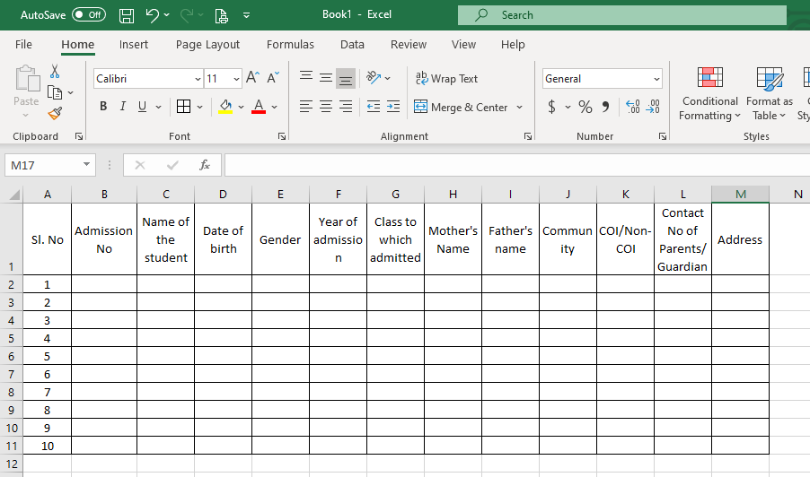

1. While filling the data we need to be careful while typing the data. Example of inappropriate data is shown below.

As seen in the above entries, entries in Column D, E, G and J are different. In column D the date format is different, in column E the capitalization is different, in column G the number formats are also different and in column J abbreviations and full forms both are included. So, we need to be careful that only one uniform format in every column.

1. We can fill innumerable number of data’s in the spreadsheet.
2. The data looks cluttered in the beginning but if care is taken during filling data’s we can filter out the required data as per our requirement.
3. The important thing is that the format of data must be same.

**Filtering students’ performance:**

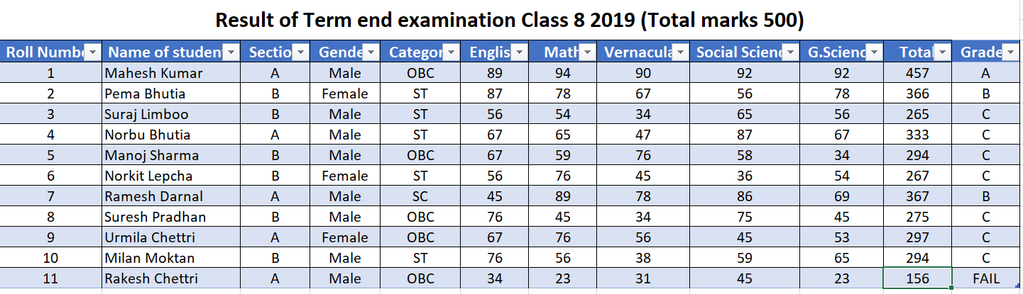

1. The above chart shows the performance of 11 students of class VIII in the term end examination in 2019.
2. 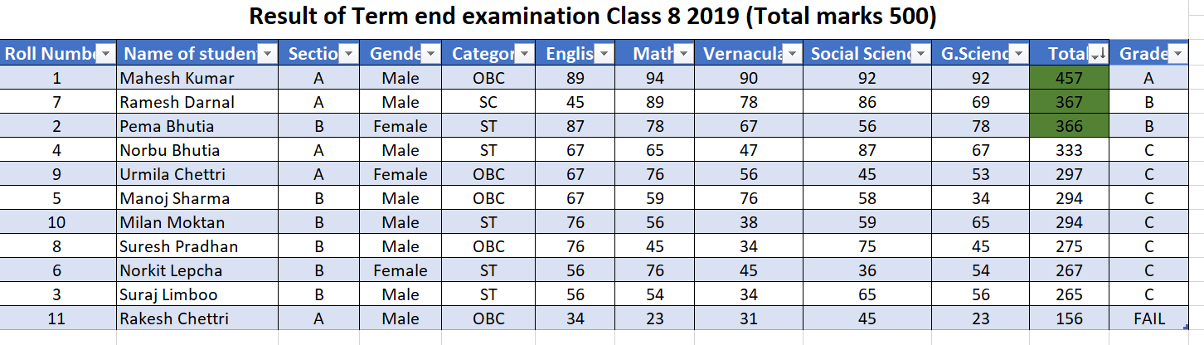The principal need to find the top three performers so they can filter the total column.
3. Similarly we can find different required data by adding filters in the spreadsheets.

**FILTERING DATA IN PIVOT TABLES**

1. The easiest way to filter data is convert the data into a tabular format.
2. It can be done by going to “INSERT” tab in the ribbon bar and clicking on “TABLES”.
3. The following option appears.

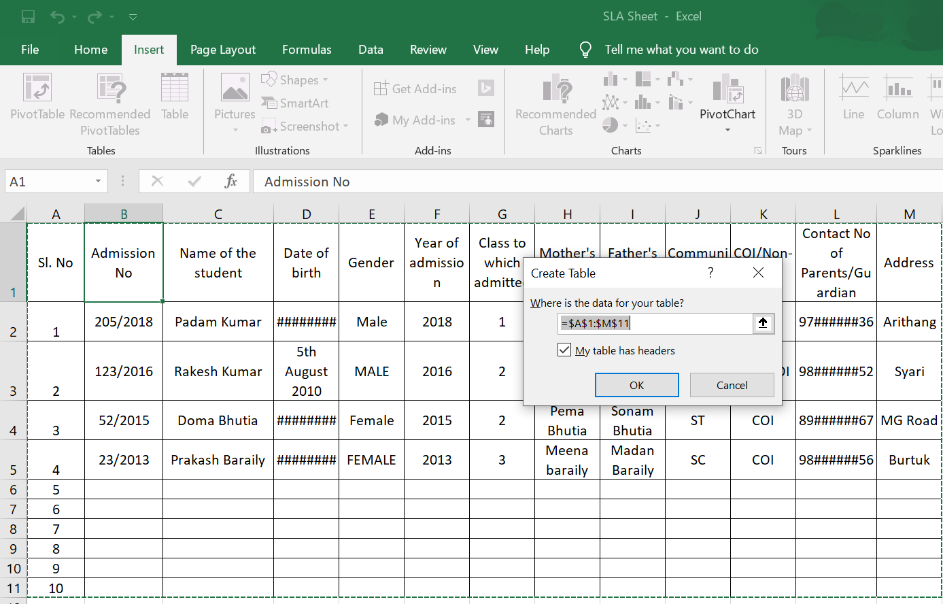

1. Click on Ok and then the tabular for appears.

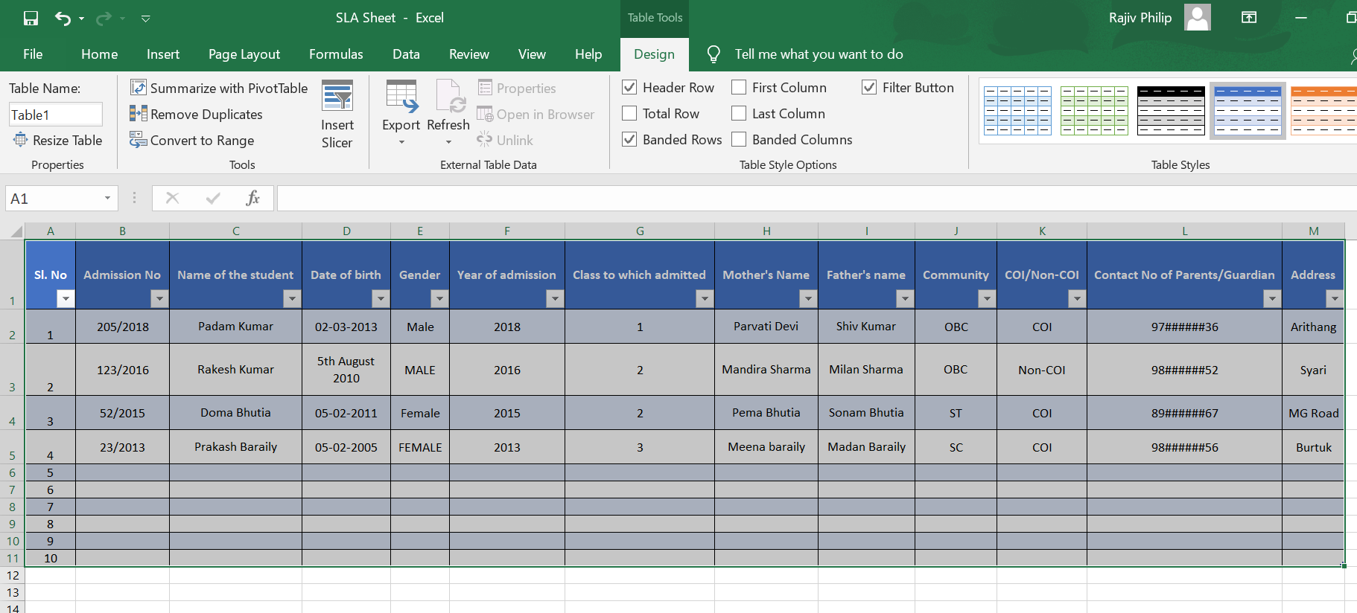

1. The data can be filtered from the drop-down tab with all the possible options given as per the criteria.
2. Another option is to use “PIVOT TABLES” once again from Insert Tab and click on it

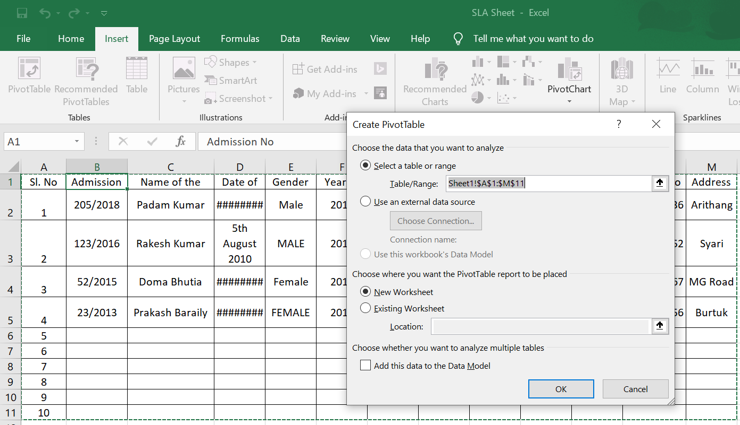

1. The above page appears and after clicking Ok the following page appears.

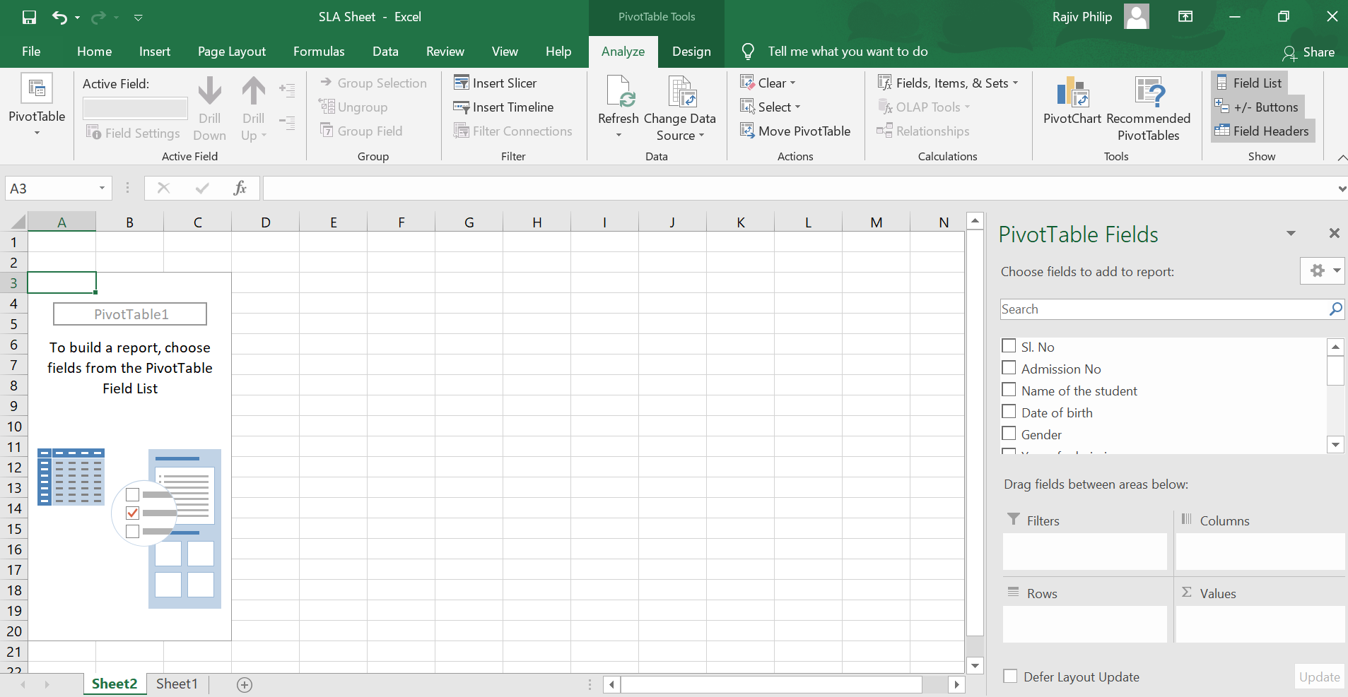

1. From the following page we can filter data as per our needs. For example, if the school requires “GENDERS” as the field it can be done by dragging gender to rows and values box.

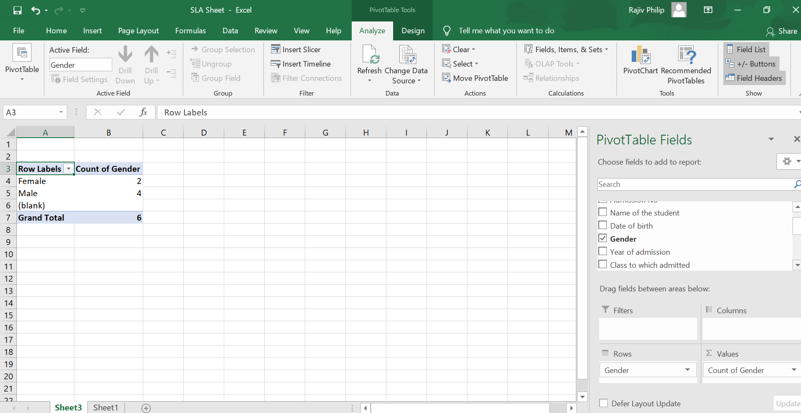

1. The following table gives the counts of student’s gender wise. Similarly, the table below gives the admission of children year wise.

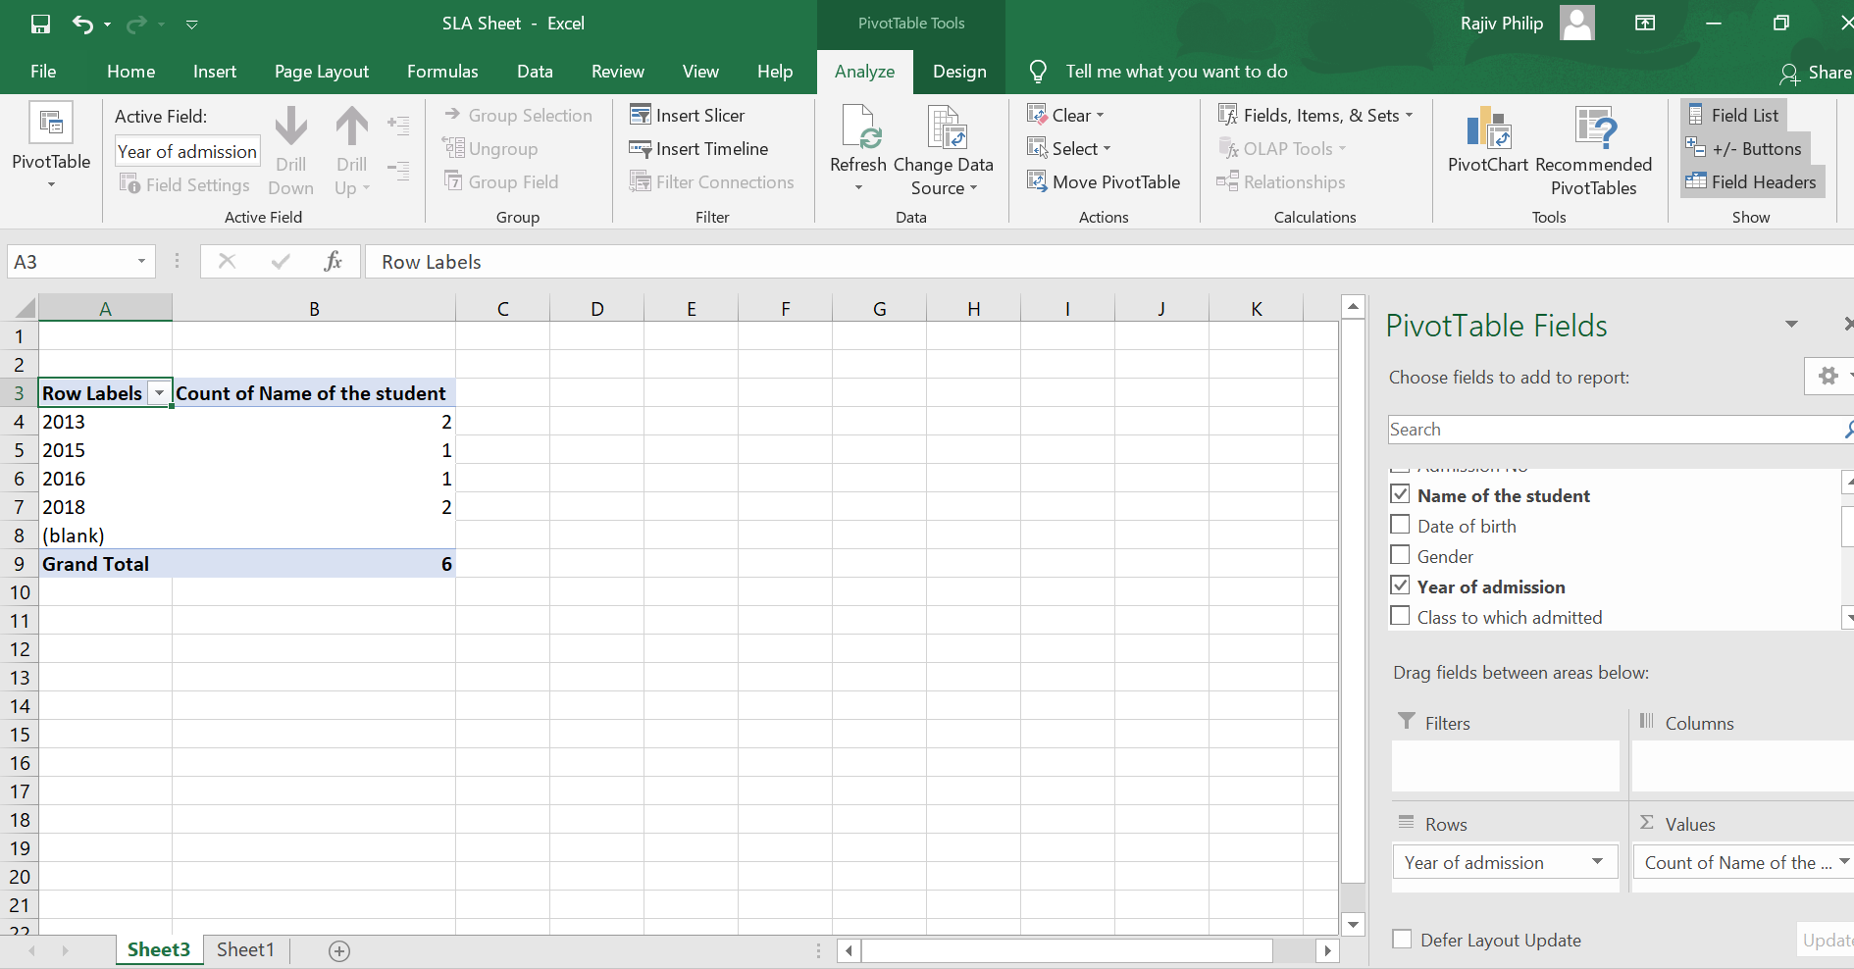

1. This table can give the gender wise admission in each year.

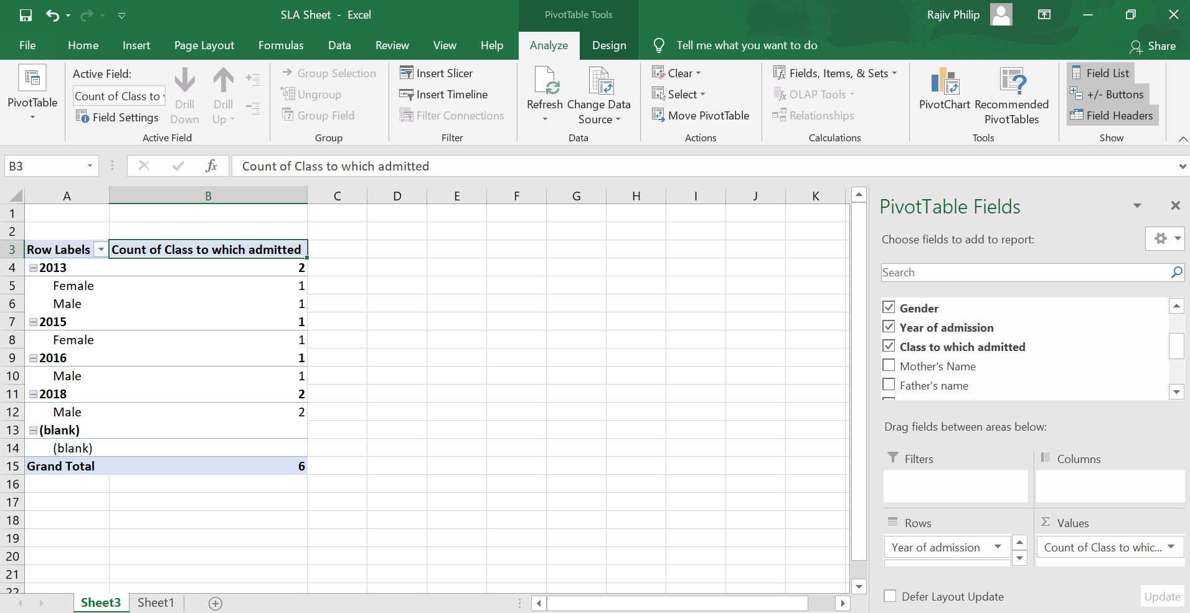

**Conclusion:**

1. The module will help the school heads to have data at their fingertips.
2. The modules also help them to segregate data in whatsoever form they want.
3. The data analysis will always help them to plan for the year as well as year ahead.
4. The module will also help them in having the contact list of all parents.

**Activity:**

1. Can you find out the total number of student’s class wise and gender wise this year?
2. Please filter out the name of students who have taken limbo as vernacular for this year in the upper primary classes?
3. Can you give the names of all the students who scored more than grade ‘B’ in class VIII?

Dear Sir,

Kindly find the module. I went through the comments and would request the team who have commented to go through the Handbook once again as

the examples have already been dealt with so no repetition is required. My module is only for the school heads to arrange and filter school data as the requirements. The module will not be able to cover the whole process as pictures and charts are required.

If they feel this module is of no use then let them exclude it.

|  |
| --- |
| i) E**xamples of various data available in school to be mentioned in the Introduction section like Scholastic & Co-scholastic Marks, Grades, Result, etc. along with student & staff bio-data**  ii) Learning Objectives, Keywords, Let’s sum up, Reference should be mentioned.  iii) It would be better if ‘how to conduct the Activity’ is elaborated ( since only Activity is written).  iv) Activity on Interpretation of Data can be designed.  v) Large Group Discussion on ‘Significance of Data management’. |

With Regards,

Rajiv Philip,

Lecturer, SCERT,HRDD,

Govt. of Sikkim,

Ph: 8172023424 & 7001414189